***TRADE GUIDE***

*A*

*Project Report*

*Submitted in partial fulfilment of the*

*Requirements for the award of the Degree of*

**BACHELOR OF ENGINEERING**

IN

**INFORMATION TECHNOLOGY**

By

**JOSHUA PETER (1602-19-737-075)**

**B SRI KANISHKA REDDY (1602-19-737-111)**

**S. SRICHARAN (1602-19-737-112)**

*Under guidance of*

**KEZIA RANI AND HASEEBA YASEEN**

**Professor**



**Department of Information Technology**

**Vasavi College of Engineering (Autonomous)**

**(Affiliated to Osmania University) Ibrahimbagh,**

**Hyderabad-31 2021-2022 Vasavi College of Engineering (Autonomous)**

**(Affiliated to Osmania University) Ibrahimbagh, Hyderabad-31**

**Department of Information Technology**



**DECLARATION BY THE CANDIDATES**

We, **JOSHUA PETER, B SRI KANISHKA REDDY, S. SRICHARAN** bearing hall ticket numbers, **1602-19-737-075, 1602-19-737-111, 1602-19-737-112** hereby declare that the project report entitled “**TRADE GUIDE**” under the guidance of **KEZIA RANI**, **HASEEBA YASEEN** Professor, Department of Information Technology, Vasavi College of Engineering, Hyderabad, is submitted in partial fulfilment of the requirement of MINI PROJECT of V semester of **Bachelor of Engineering in Information Technology**.

This is a record of bonafide work carried out by us and the results embodied in this project report have not been submitted to any other university or institute for the award of any other degree or diploma.

**JOSHUA PETER (1602-19-737-075)**

**B SRI KANISHKA REDDY (1602-19-737-11)**

**S. SRICHARAN (1602-19-737-112)**

**Vasavi College of Engineering (Autonomous)**

**(Affiliated to Osmania University) Ibrahimbagh, Hyderabad-31**

**Department of Information Technology**



**BONAFIDE CERTIFICATE**

This is to certify that the project entitled " **TRADE GUIDE**” being submitted by **JOSHUA PETER, B SRI KANISHKA REDDY, S. SRICHARAN** bearing **1602-19-737-075, 1602-19-737-111, 1602-19-737-112** in partial fulfilment of the requirements for the completion of MINI PROJECT of Bachelor of Engineering in Information Technology is a record of bonafide work carried out by them under my guidance.

**KEZIA RANI, HASEEBA YASEEN**

**Dr. K. Ram Mohan Rao**

**Professor HOD, IT**

**Internal Guide**

**ACKNOWLEDGEMENT**

The satisfaction that accompanies that the successful completion of the project would not have been possible without the kind support and help of many individuals. We would like to extend my sincere thanks to all of them. We would like to take the opportunity to express our humble gratitude to **KEZIA RANI**, **HASEEBA YASEEN, MUKESH TRIPATHI** under whom we executed this project. We would also use this opportunity to thank our Head Of Department Dr. K.Ram Mohan Rao. We would also like to thank all faculty members and staff of the Department of Information Technology for their generous help in various ways for the completion of this project.

**INDEX**

**Abstract**

**CHAPTER 1**

**Title and Description 1**

1.1 Motivation 1

**CHAPTER 2**

**Software Requirements Specifications 2**

2.1 Introduction 2

2.1.1 Purpose 2

2.1.2 Scope 2

2.1.3 Definitions, Acronyms and Abbreviations 2

2.1.4 Overview 2

2.2 General Description 3

2.2.1 Product Perspective 3

2.2.2 Product Functions 3

2.2.3 User Characteristics 3

2.3 Modules Description 3

2.4 System Requirements 4

2.4.1 Hardware Requirements 4

2.4.2SoftwareRequirements 4

2.5 Design Constraints 5

**CHAPTER 4**

**System Design 6**

4.1 Architecture and Technology used 6

4.2 UML Diagrams 8

4.2.1 Use-case Diagram 8

4.2.2 Sequence Diagram 9

**CHAPTER 5**

**Implementation 10**

5.1 System Architecture (design) 10

5.2Github link 11

**CHAPTER 6**

**Results 12**

6.1 Database Design 17

**CHAPTER 7**

**Testing 18**

**CHAPTER 8**

**Conclusion 19**

**Future Scope 20**

**CHAPTER 9**

**References 21**

**ABSTRACT**

The nature of stock market movement has always been ambiguous for investors because of various influential factors. So, without a proper knowledge about the crypto or stocks or shares of a certain company and their past performances, their money is significantly at a high risk. So, the trading guide is an online platform to know and learn about how the exchange works in the current world. How to trade and when to trade (to know the right time to invest) and to be up to date with the opportunities in the market. Here at trade guide, we aim to help educate the world on the ever-growing crypto currency market. And to help them become confident and successful trader. From understanding how crypto works to learning how to invest into it. The trading guide helps us in giving basic knowledge and the befits on long term and short-term trading and helps us to know when to invest so that the risk is minimized. It helps to know how actual value of a particular cryptocurrency has been changing according to trends in the market. These statistics such as change in value for past will be more helpful for the user to invest in crypto. In this way the trade guide helps the user to learn and to invest in different crypto currencies.

**CHAPTER 1**

#### 1.1 Motivation

A new user will always be perplexed about their future. The way he/she must prepare for their goals. The way he/she must update him/herself every day. In the ever-growing world with a new upcoming technology striking us every day it really is a challenge for any investor to cope up with the amount of competition to secure their good investing share. Trade guide will help these investors to learn the required strategies for the investments. Visual simulations will help them understand the trading strategies effectively and efficiently. With access to previous statistics and current trends, the investors will be able to trade in the market without any confusion and with a better clarity.

**CHAPTER 2**

**software requirements specifications**

**2.1 Introduction**

#### 2.1.1 Purpose

In search of proper platform that aids the investors in cracking the interviews in top-notch crypto coins by helping them understand the subject easily through visual simulations and boost their confidence by providing them with multiple statistics of various crypto’s. Trade Guide is a web application which we have developed to provide a platform to investors who are lacking the trading skills needed at present and are willing to learn these skills. Visual simulations will ensure their maximum understandability.

#### 2.1.2 Scope

With the help of this website users(investors) will be able to stabilize their thoughts on how to prepare for the crypto investments and what to prepare. With ever-growing technologies and a new market trend showing up every day, users will be able to access the desired coins and their trends instantly.

#### 2.1.3 Definitions, Acronyms and Abbreviations

**2.1.4 Overview**

The specifications include product perspective and the functionalities that the system will provide. The user characteristics, any general constraints or assumptions and dependencies are discussed below.

Requirements are categorized as performance, non-functional requirements and design constraints. Non-functional requirements are scalability, maintainability and dependence.

## 2.2 General Description

#### 2.2.1 Product perspective

#### Trade Guide provides features for client users such as stocks prediction i.e., accessing the desired crypto currencies, build their own trading strategies exclusively, learning and understanding everything through VS. The current design goal is to build a system to achieve the functionality outlined in the specification.

#### 2.2.2 Product Functions

#### Trade guide gives users a list of all the required top-notch crypto currencies with their current and correct statistics i.e., about their previous values, their present market cap and their future scope etc.

#### 2.2.3 User Characteristics

1. **Student/user:** 
   * + The user can register in our website free of cost.
     + He/she can and access the features after logging in.
     + They can access this platform for learning and analysing different crypto statistics and start investing.

1. **Administrator:** 
   * + Admin is responsible for maintaining and updating website
     + Admin has access to database.

**2.3 Description of Main Modules**

* **Login/Signup:**

In this module, the user can log into their respective accounts and use the website as desired. If the student is not an already existing user, he/she can create a new account by signing up.

* **How To Trade:**

This module explains the strategies to the users for investing in different crypto currencies. And to get a clear-cut idea what exactly the crypto’s are.

* **Different Crypto’s:**

There are different crypto currencies in the market like bitcoin, polygon, Ethereum etc. And this module explains the users to know about them and invest in the crypto coin in which they are interested.

* **Statistics And Trends:**

This module gives the live data about the crypto’s and their previous trends and statistics to the users so that he/she may get some idea of their current value in the market and also be able to predict their value or scope in the future.

## 2.4 System Requirements

#### 2.4.1 Hardware Requirements

* 1GB RAM
* 1GB CORE

#### 2.4.2 Software Requirements

* **XAMPP:**

XAMPP  is a [free and open-source](https://en.wikipedia.org/wiki/Free_and_open-source) [cross-platform](https://en.wikipedia.org/wiki/Cross-platform) [web server](https://en.wikipedia.org/wiki/Web_server) [solution stack](https://en.wikipedia.org/wiki/Solution_stack) package developed by Apache Friends, consisting mainly of the [Apache HTTP Server](https://en.wikipedia.org/wiki/Apache_HTTP_Server), [MariaDB](https://en.wikipedia.org/wiki/MariaDB) [database](https://en.wikipedia.org/wiki/Database), and [interpreters](https://en.wikipedia.org/wiki/Interpreter_(computing)) for scripts written in the [PHP](https://en.wikipedia.org/wiki/PHP) and [Perl](https://en.wikipedia.org/wiki/Perl) [programming languages](https://en.wikipedia.org/wiki/Programming_language). Since most actual web server deployments use the same components as XAMPP, it makes transitioning from a local test server to a live server possible.

* **INTERPRETER:**

Visual Studio Code- It features a lightning-fast source code editor, perfect for day-to-day use. With support for hundreds of languages, VS Code helps you be instantly productive with syntax highlighting, bracket-matching, auto indentation, box-selection, snippets, and more.

• **BOOTSTRAP- WEB DESIGNING:**

Bootstrap is a free and open-source front-end framework for designing websites and web applications. It contains HTML- and CSS-based design templates for typography, forms, buttons, navigation and other interface components, as well as optional JavaScript extensions.

## 2.5 Design Constraints

* Software Constraints: Users can run this application in windows.
* Hardware Constraints: The system will run on a core processor with minimum 400MB ram.
* Acceptance Criteria: Before accepting, the developer must check whether the application is running properly or not and should also check whether the data is stored correctly.

**CHAPTER 4**

**4.1 Design**

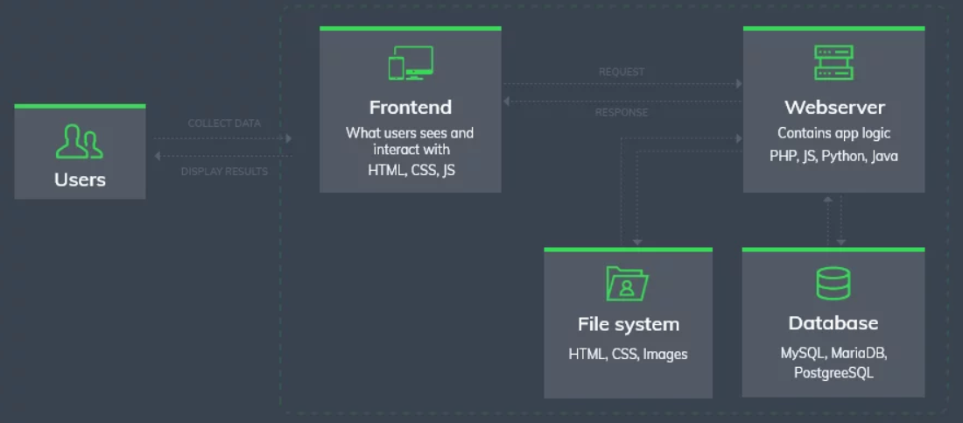

**Architecture and Technology Use**

**Front-End:**

1. HTML
2. CSS
3. JAVA SCRIPT
4. BOOTSTRAP

**Back-End:**

1. PHP

**RELATED WORK**

**Market Research:**

[**CoinDesk**](https://www.coindesk.com/indices/) are the bellwether for the market. They are the industry standard for institutional-grade cryptocurrency pricing with billions of dollars in monthly trading volume quoted against them. The flagship [CoinDesk Bitcoin Price Index (XBX)](https://www.coindesk.com/indices/xbx/) is a spot reference rate for BTC that benchmarks the world's first publicly traded bitcoin fund and the world's first bitcoin ETF.

**Cointelegraph** covers everything FinTech, Blockchain, Bitcoin, bringing you the latest news, prices, breakthroughs and analysis from across the future of money.

**Areas our project can be improved in:**

* The platform to be available 24/7 to the sellers and the buyers so that they can invest in crypto’s whenever they want from where ever they are using this platform.
* Making it user friendly by giving an option of depositing and withdrawal anything they need.
* Friendly crypto’s that depicts the user that when and how much profit did he/she earns while investing in a particular crypto coin.
* And also, an option like that prevents the user from risky choices.

**4.2 UML Diagrams**

**4.2.1 Use Case:**

Use case diagrams are the diagrammatic representations depicting users' interactions with the system. This diagram shows different types of users and various ways in which these users interact with the system.

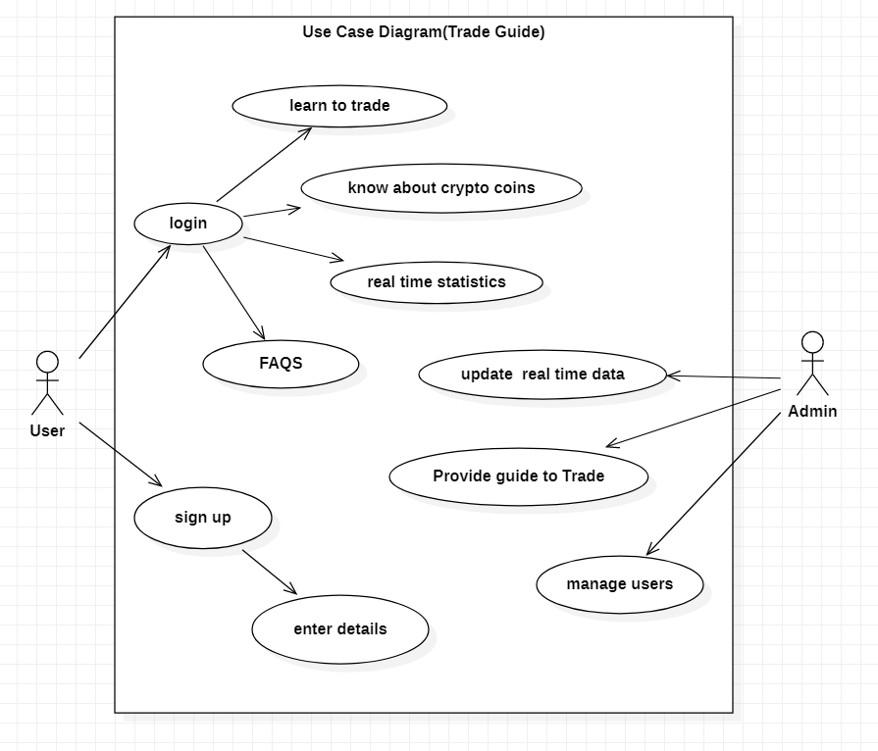

* + 1. **Sequence Diagram**

Sequence diagrams establish the roles of objects and help provide essential information to determine class responsibilities and interfaces. This type of diagram is best used during early analysis phases in design because they are simple and easy to comprehend. These are normally associated with use cases and are closely related to collaboration diagrams and both are alternate representations of an interaction.

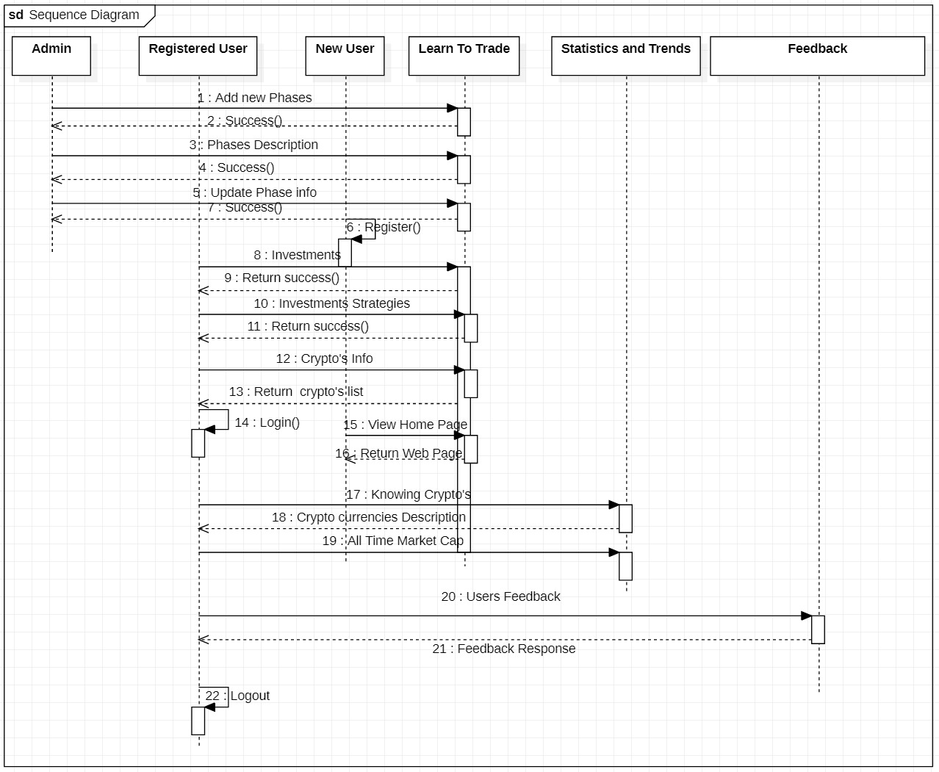

**Chapter 5**

**IMPLEMENTATION**

* 1. **System Architecture (Design)**

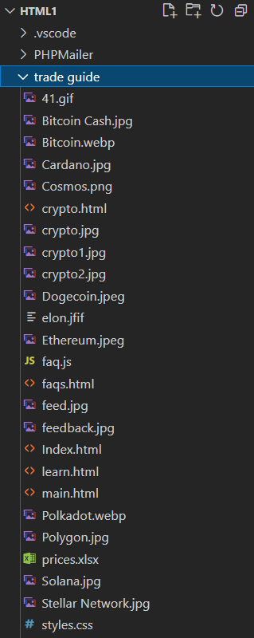 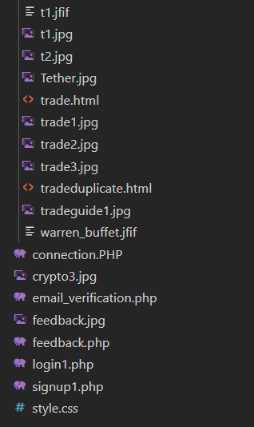

**5.2 Github Links and Folder Structure**

[**https://github.com/joshua-peter/Trade-Guide**](https://github.com/joshua-peter/Trade-Guide)

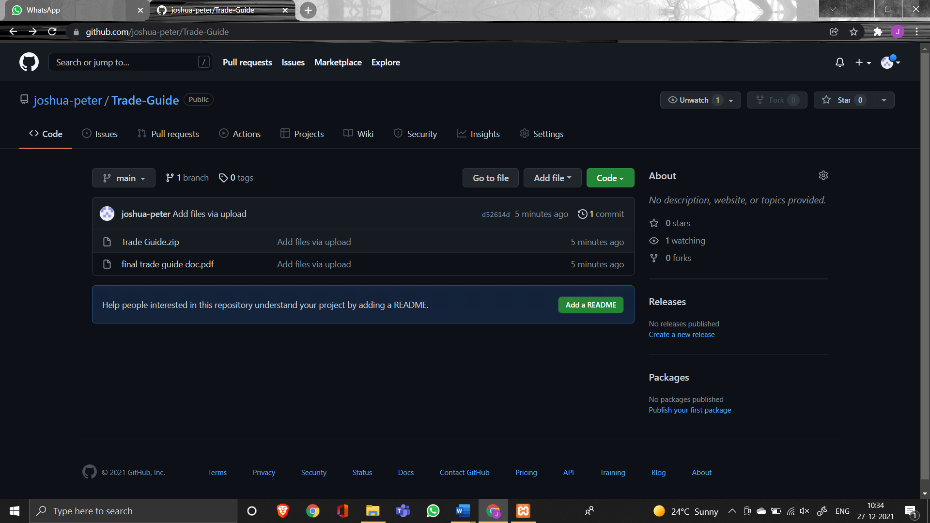

**CHAPTER 6**

**RESULTS**

**Home Page: -**

**Must know Coins and People**

**Different Crypto Coins:**

**CRYPTO VALUES AND TRENDS: -**

**Very Frequently Asked Questions: -**

**FEEDBACK FORM: -**

**Database Design: -**

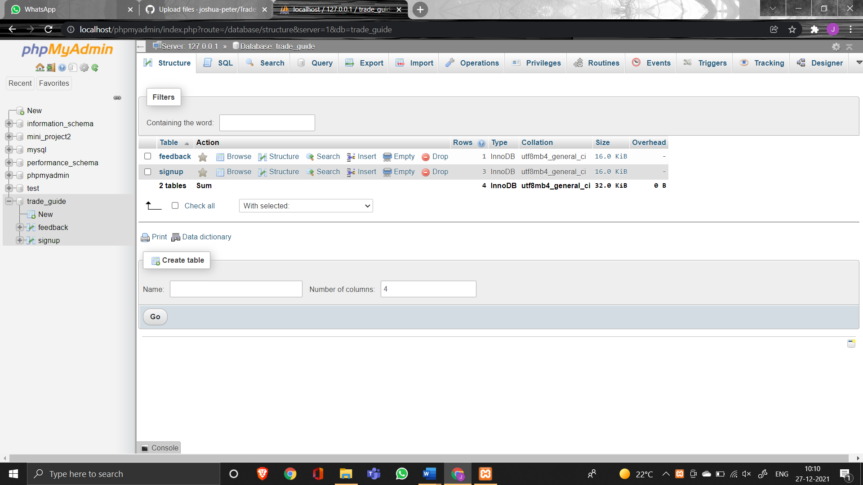

**Chapter 7**

**TESTING**

* Password is validated using php built in password hashing mechanism.
* The password should have atleast 8 characters of length. It should have capital alphabet, numbers and special characters also. If not so it asks to re-enter the password as it is invalid.
* The account is verified only if the email is sent to the user and click the link for activating the account.

**CHAPTER 8**

**CONCLUSION AND FUTURE WORK**

**Conclusion:**

So, we conclude that crypto market is unpredictable but through a detailed case study and certain references even the crypto’s are predictable.

In our project we provide a webpage that acts as an interface between the traders and the investors. One can gain a sufficient knowledge about the crypto currencies through our portal and they may be in the position of investing in the crypto currencies and may also be able to trade.

Crypto Market are the best alternative for business to grow and it's a side way income for the individuals who are ready to invest and earn from the same. The term crypto had been in picture ever since and it's growing in bulk every day. There are thousands of investors investing on the same and making the fortune out of it.

There are middle level agents and crypto vendors who learn and invest on the same. The cost for the consultation on the crypto is bulky and expensive. When it comes to people, they think a lot and invest and there's no chance and certainty for the same to produce a yieldful result.

So, crypto being unpredictable and the tendency of its growth is higher than ever. If the crypto market and its prediction can be done accurate than it's going to be a gain for both the individuals and the organization. The risk factor has to be mitigated so the efficiency of the system should be high and people can be certain about their investment in time.

**Future work**:

* The project can be further continued to gain the effectiveness of the prediction with addition implementations of the content that can involve real time scenario and the way of executing and processing the real time scenario. Various constrains has to be added and performance of the same can be acylated in the future time for the effective results.
* The expected form of the display is graph whereas from the same the more appearance and setting of the display can be integrated and a pie-chart and a custom graph can further me implemented on the same.
* The integration of new technologies into the banking system may drive the prices of crypto currencies to new hights.
* Proponents see limitless potential while the critics see nothing but the risk.
* In future it will act as an interface between the sellers and the buyers so that they can invest in crypto’s whenever they want from where ever they are using this platform.
* We are also interested in introducing new module like
* Friendly crypto’s that depicts the user that when and how much profit did he/she earns while investing in a particular crypto coin.

**CHAPTER 9**

**REFERENCES**

* <https://www.researchgate.net/publication/286056422_Towards_Reference_Architecture_for_Cryptocurrencies_Bitcoin_Architectural_Analysis>
* <https://www.bankrate.com/investing/types-of-cryptocurrency/>
* <https://en.wikipedia.org/wiki/Cryptocurrency>
* <https://www.apachefriends.org/index.html>
* <https://www.tradingview.com/markets/cryptocurrencies/prices-all/>
* <https://www.w3schools.com/>

**THANK YOU**